**Sunkari Manohar**

**Aditya Institute of Technology and Management**

**Assessment 7 - 11/12/2023**

**Cleaning dataset:**

* row number.

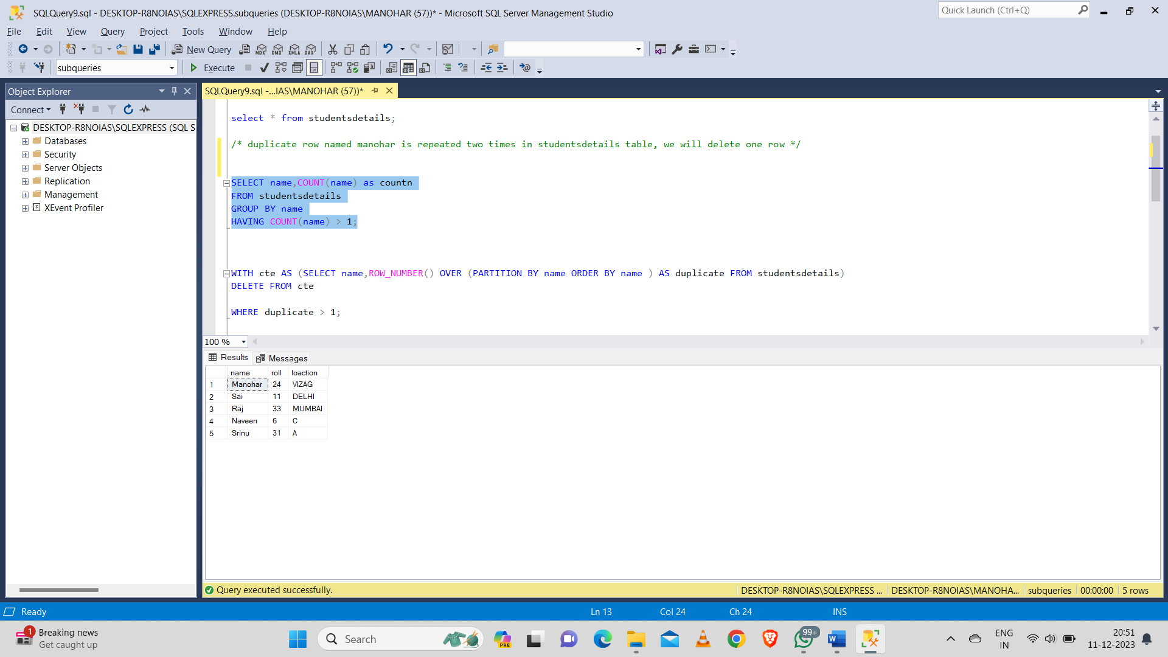

* Delete the data using CTE, row number():

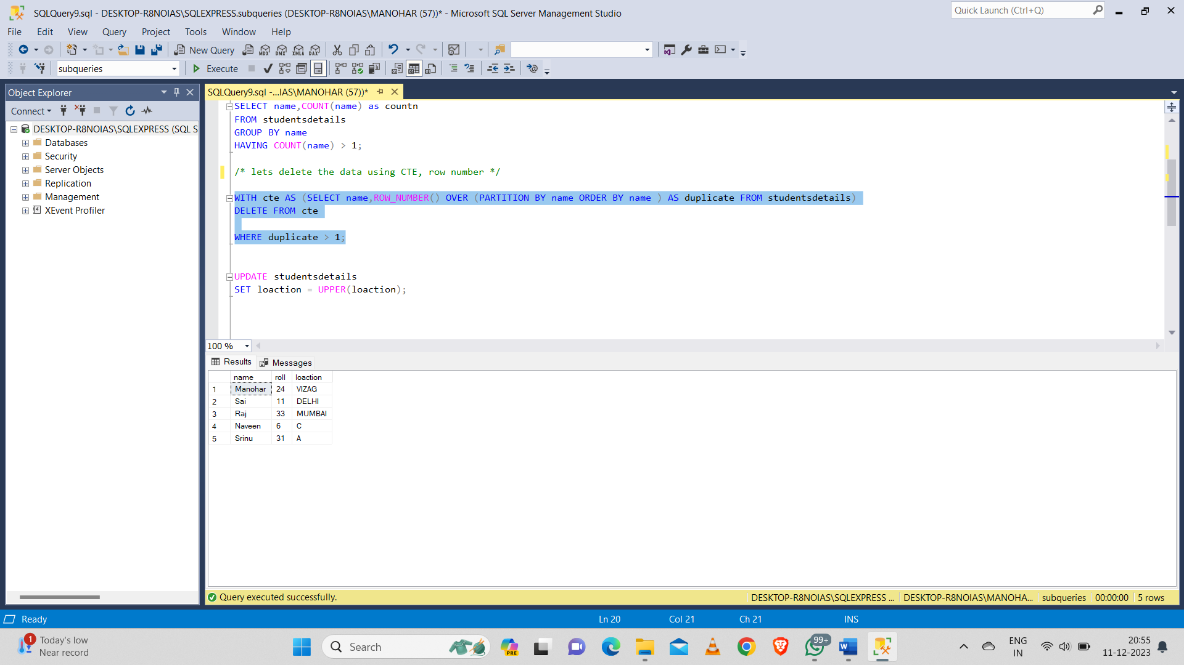

**Updating the table:**

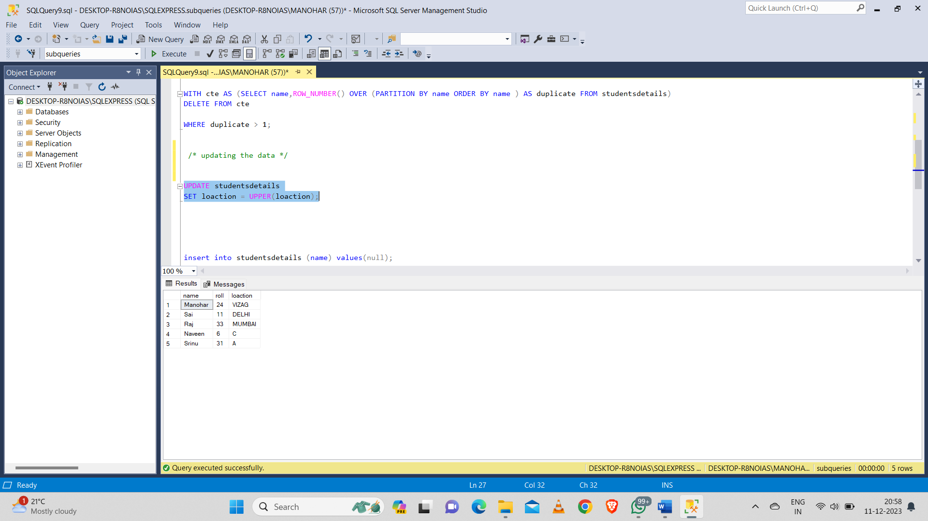

**Inserting null values:**

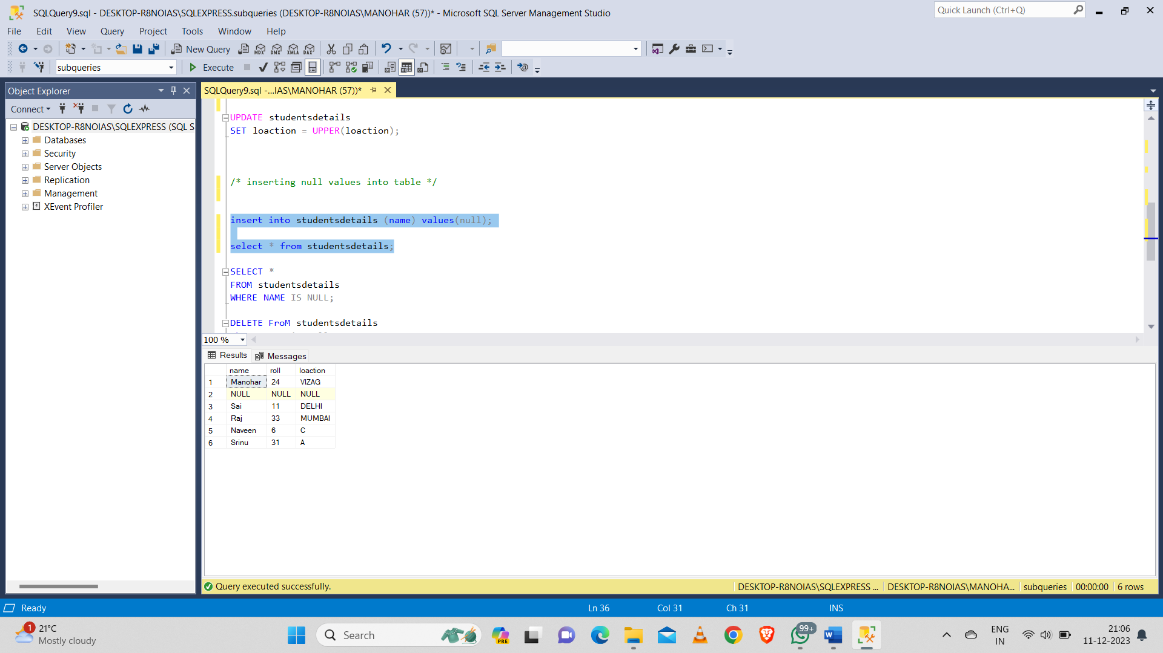

**Deleting null values:**

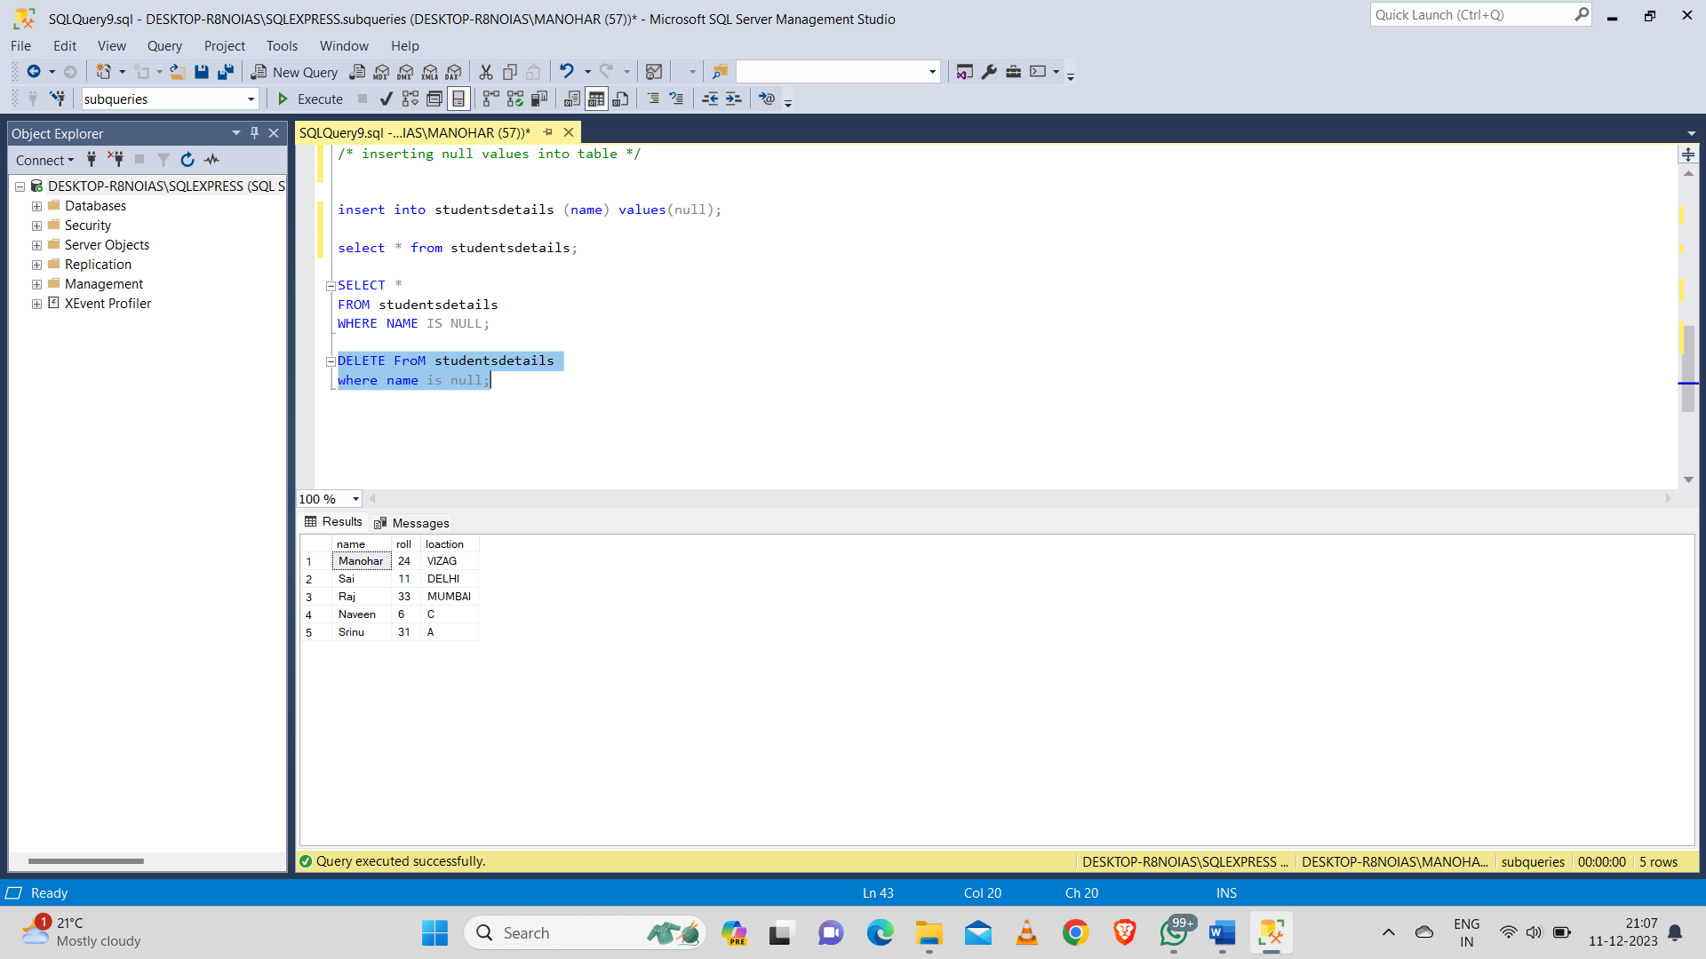

**Database Diagrams:**



**Partition By:**

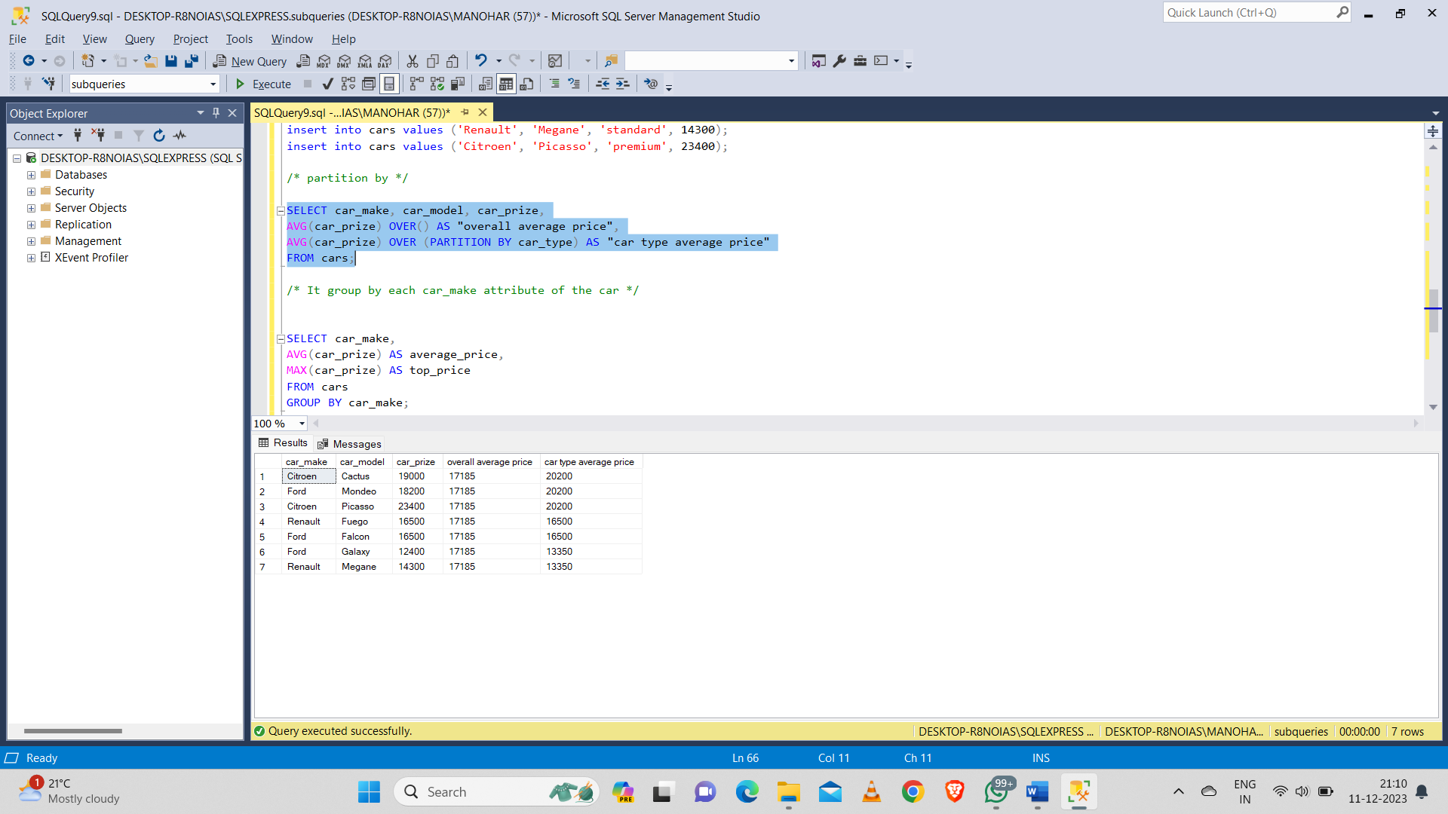

**Group by each car_make attribute of the car:**

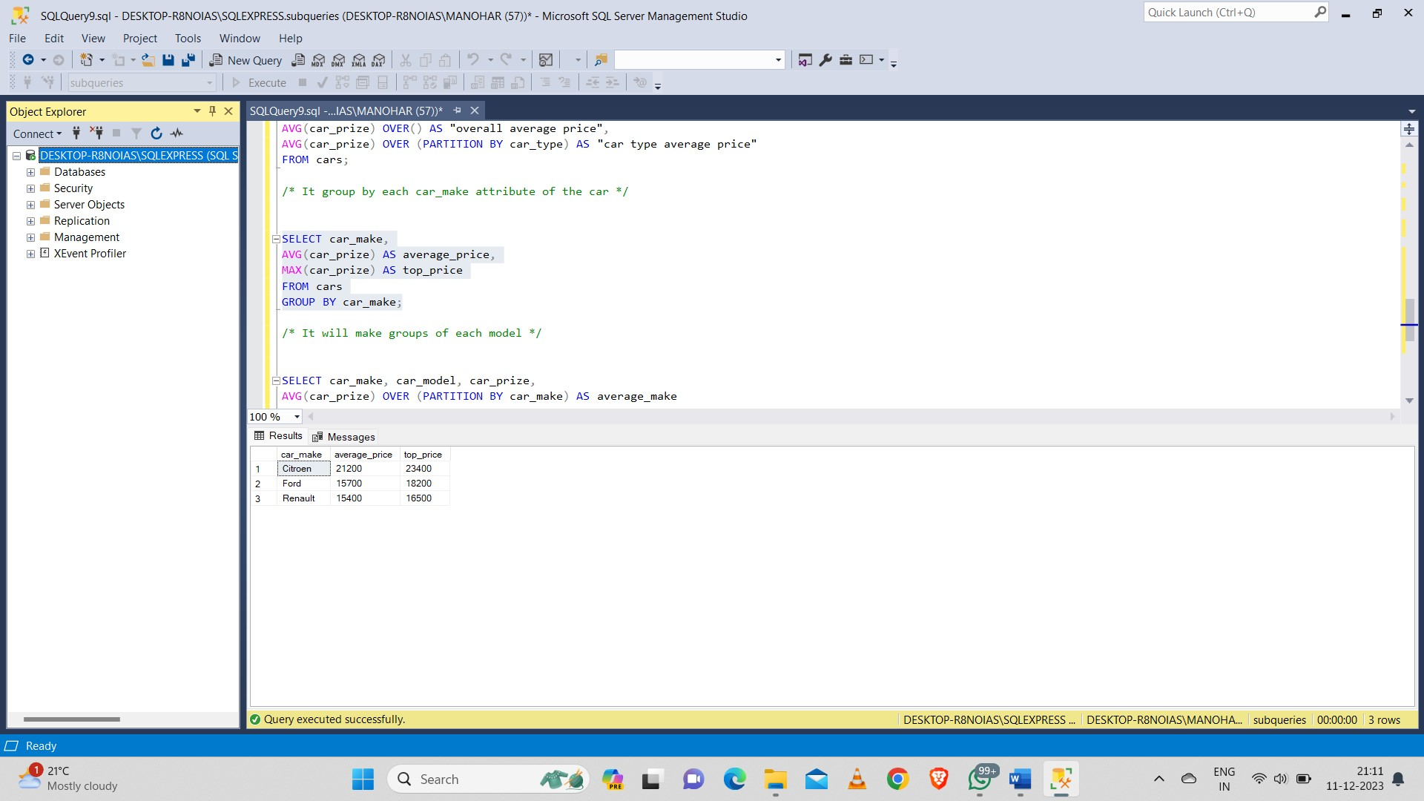

**It will make groups of each model:**

